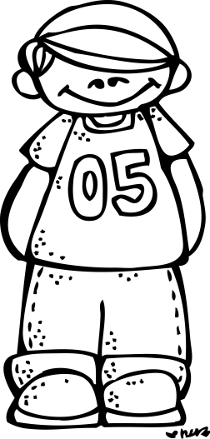**Mrs. Darden’s Rules and Class Discipline Plan**

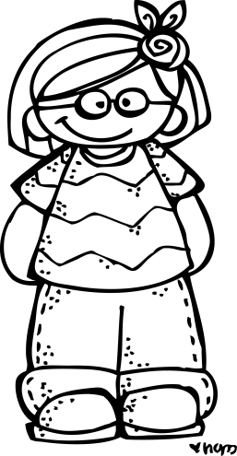For the next year, our class will be your child’s “family away from home”, and part of my job is to help the children become caring, productive and social beings. I encourage respect for all, polite language, patience with others, self-control and a good work ethic. We are all learners and we usually try our best. Mistakes will be made, but every day brings a fresh beginning. My classroom discipline plan helps every student receive guidance in making good decisions about his/her behavior. In doing this, the children are given the opportunity to learn in a positive, nurturing classroom environment. In the beginning years, it is so important for each child to develop self-discipline and good work habits, resolve conflicts peacefully and think independently. Your child deserves the most positive educational climate possible for his/her growth. I believe that working together; we can make a difference in this process.

The plan below outlines our classroom rules, the clip chart system and positive rewards and consequences for appropriate and inappropriate behaviors.

**Our Rules**

1. Follow directions (the first time they are given).

2. Keep hands, feet and negative comments to yourself.

3. Be kind to other children and adults in the classroom. Show respect always!

4. Take good care of class materials and clean up things when you are finished with them.

5. Always walk in the hallways and classroom.

6. Raise your hand when you need to share something with the class and wait for your turn.

7. Use a soft voice in the classroom and save your loud voice for outside.

8. Share!

**The Clip Chart**

Each student will start daily with his/her clothespin on “**Ready to Learn**”. Throughout the day, students will be asked to move their clips up or down on the chart according to their behavior. If a student makes improved choices after moving their clip down, they will be given a chance to move their clip back up. I will mark each student’s behavior chart in their notebook to show you where ****his/her clip is at the end of the day. If students move their clip to orange or red, I will send a note explaining why they moved their pin down.

**Clip Chart Levels**

**Pink (Super Student) -** This level is reserved for extraordinary behavior and will not be given out loosely. I want this to remain special; please don’t expect your student to reach this level daily.

**Purple (Great Choices) –** Students on purple continue to make excellent choices and have outstanding behavior.

**Blue (Good Choices) –** Students move their clip to blue for making good choices, trying their best, and showing good character. This is a good level to end the day on!

**Green (Ready to Learn) -** This is an acceptable level to stay at. If students end the day on this level they did not get in trouble, it just means they didn’t go “above and beyond.”

**Yellow (Think About It!) -** Students move to this level as a reminder that they need to follow the classroom rules.

**Orange (Teacher’s Choice) –** Students move to orange if they continue to have a hard time making good choices. The teacher will choose a consequence such as: taking a time out, loss of recess time, loss of privilege; phone call home, whatever is logical for the misbehavior and meaningful to the student.

**Red (Parent Contact/Office) –** Students who move their clips to red have continued to struggle with their behavior. These students will receive an office referral, have their parents contacted and have a consequence.



**Rewards**

In order to encourage students to follow the rules and make good choices about their behavior, I like to praise the children for their efforts in fun and creative ways. I will reward consistent good behavior with positive praise. On Friday, if your child has not ended the day on red or orange for the week, he/she will go to the treasure chest or will receive a special treat.

Please check and sign your child’s notebook daily. It is important to reinforce good behavior and discuss solutions for problem behaviors with your child. I look forward to a great year. Thank you in advance for your help!